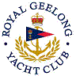 | Royal Geelong Yacht Club Inc.  Est 1859
Trophy Deed of Gift.

Trophy: | Power Drive Sails Trophy (inc Tuff Marine)
Presented by: | Ruth Plummer (prop)
Date: | 1976
For: | Flying Fifteen Class Aggregate
Remarks / Revisions | 1986: Reallocated to the Tuff Marine evening races
Click here for a list of Flying Fifteen Recipients.
Click here for a list of Tuff Marine.

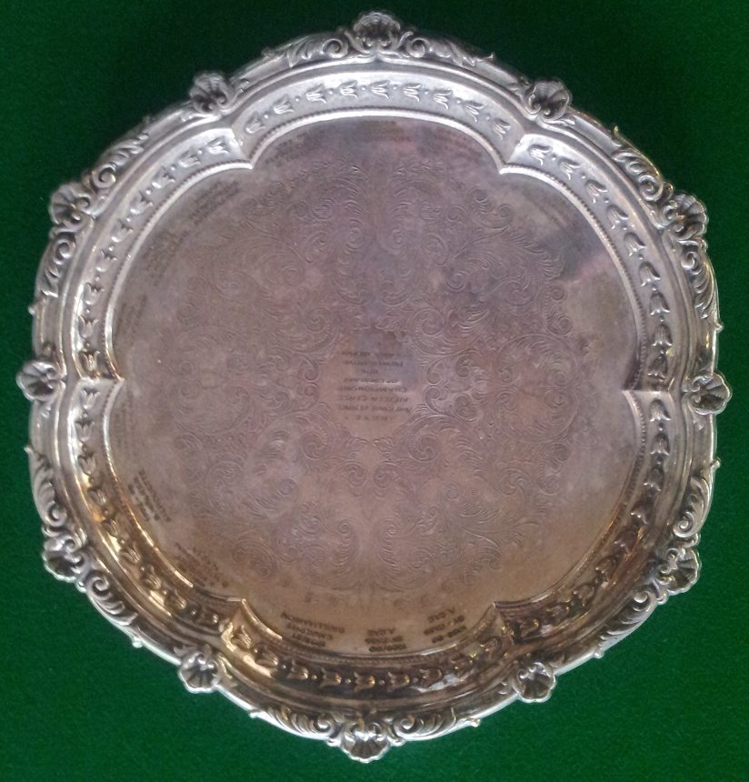

Editor’s Note
‘Tuff Marine’ was the brand name of Sailing apparel and life jackets.
Prior, the business also made sails, sold under the ‘Power Drive’ brand, in association with Ron Kirby.
In later days, the sail making arm of the business was sold, and the business concentrated on apparel and life-jackets under the ‘Tuff Marine’ brand.
The business was owned by (Hon Life Member and Past Rear Commodore) Ruth Plummer, and operated from premises at the bay-end of Cunningham St, opposite the shore-end of Cunningham Pier.
‘Tuff’ must not be confused with ‘Tough’!!!
The trophy was Deeded in 1976 for the Flying Fifteen Class. This class ceased to be viable, and the trophy was re-deeded to the Tuff Marine series, in the days prior to Daylight Saving, GPS’s and Auto-helms. Its purpose was to give sailors some night sailing experiences and night navigation skills prior to the upcoming Christmas period off-shore racing programs run by other Organising Authorities.
As such, the start times were scheduled to be close to sun-set, with a 22:00 (or later) finish time, with the course chosen by the Race Committee to be around fixed marks in Corio Bay.
Daylight-Saving, along with user-wishes, gradually circumvented the original aims of the Deed.
There is no connection between Power Drive Chandlery and the now defunct Power Drive Sails.
19 April 2023

